[](https://ok.ru/dk?cmd=PopLayerPhoto&st.layer.cmd=PopLayerPhotoOuter&st.layer.type=GROUP&st.layer.revNav=off&st.layer.limitedUi=false&st.layer.closeLayers=off&st.layer.sphotoIds=902350332852;902350333108;902350333364;902350333620;902350333876;902350334132;902350334388;902350334644&st.layer.showNav=on&st.layer.photoAlbumId=53660988735668&st.layer.epm=off&st.layer.photoId=902350332852&st.layer.wasRedirect,=off&st.layer.opl=off&st.layer.navStartPhotoId=902350332852&st.layer.navStartAlbumId,=53660988735668&st.layer.sbd=off&st.cmd=altGroupForum&st.groupId=53660977529012&st._aid=GroupTopicLayer_openPhotoLayer)

[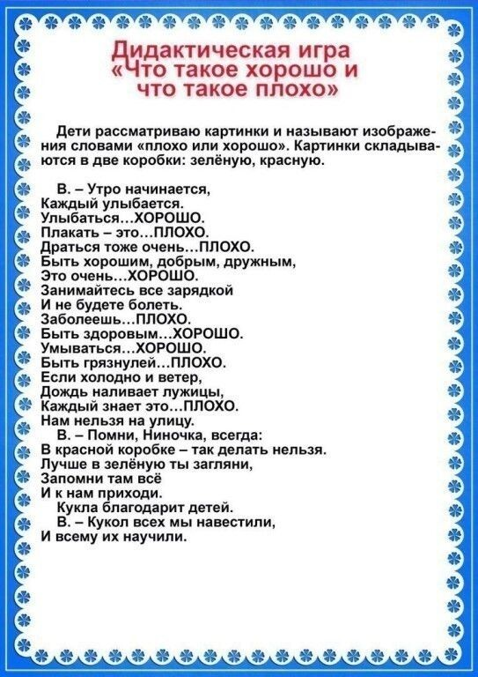](https://ok.ru/dk?cmd=PopLayerPhoto&st.layer.cmd=PopLayerPhotoOuter&st.layer.type=GROUP&st.layer.revNav=off&st.layer.limitedUi=false&st.layer.closeLayers=off&st.layer.sphotoIds=902350332852;902350333108;902350333364;902350333620;902350333876;902350334132;902350334388;902350334644&st.layer.showNav=on&st.layer.photoAlbumId=53660988735668&st.layer.epm=off&st.layer.photoId=902350333108&st.layer.wasRedirect,=off&st.layer.opl=off&st.layer.navStartPhotoId=902350333108&st.layer.navStartAlbumId,=53660988735668&st.layer.sbd=off&st.cmd=altGroupForum&st.groupId=53660977529012&st._aid=GroupTopicLayer_openPhotoLayer)

[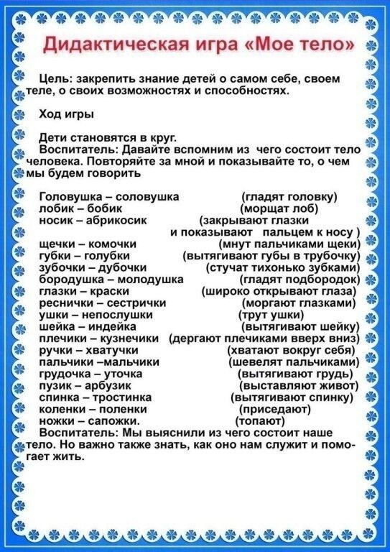](https://ok.ru/dk?cmd=PopLayerPhoto&st.layer.cmd=PopLayerPhotoOuter&st.layer.type=GROUP&st.layer.revNav=off&st.layer.limitedUi=false&st.layer.closeLayers=off&st.layer.sphotoIds=902350332852;902350333108;902350333364;902350333620;902350333876;902350334132;902350334388;902350334644&st.layer.showNav=on&st.layer.photoAlbumId=53660988735668&st.layer.epm=off&st.layer.photoId=902350333364&st.layer.wasRedirect,=off&st.layer.opl=off&st.layer.navStartPhotoId=902350333364&st.layer.navStartAlbumId,=53660988735668&st.layer.sbd=off&st.cmd=altGroupForum&st.groupId=53660977529012&st._aid=GroupTopicLayer_openPhotoLayer)

[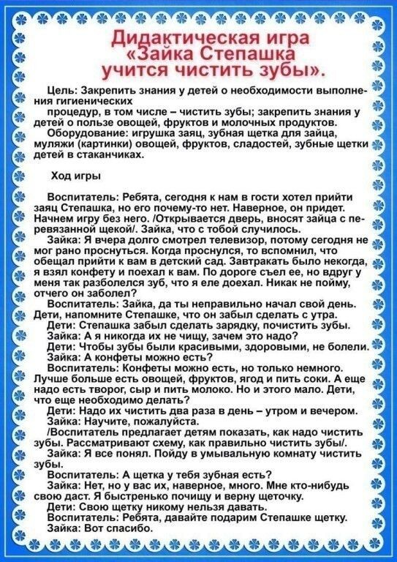](https://ok.ru/dk?cmd=PopLayerPhoto&st.layer.cmd=PopLayerPhotoOuter&st.layer.type=GROUP&st.layer.revNav=off&st.layer.limitedUi=false&st.layer.closeLayers=off&st.layer.sphotoIds=902350332852;902350333108;902350333364;902350333620;902350333876;902350334132;902350334388;902350334644&st.layer.showNav=on&st.layer.photoAlbumId=53660988735668&st.layer.epm=off&st.layer.photoId=902350333620&st.layer.wasRedirect,=off&st.layer.opl=off&st.layer.navStartPhotoId=902350333620&st.layer.navStartAlbumId,=53660988735668&st.layer.sbd=off&st.cmd=altGroupForum&st.groupId=53660977529012&st._aid=GroupTopicLayer_openPhotoLayer)

[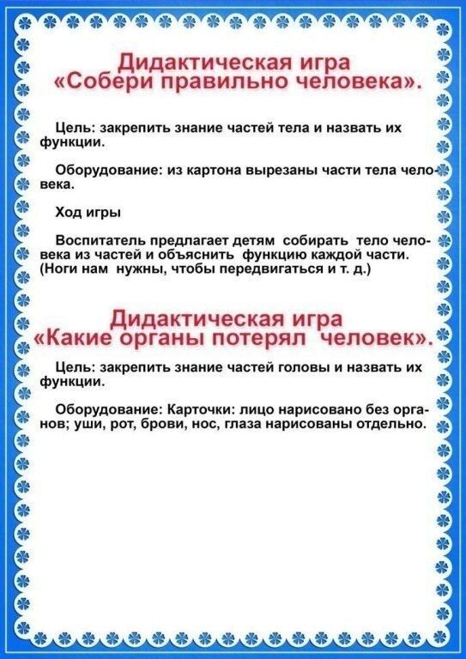](https://ok.ru/dk?cmd=PopLayerPhoto&st.layer.cmd=PopLayerPhotoOuter&st.layer.type=GROUP&st.layer.revNav=off&st.layer.limitedUi=false&st.layer.closeLayers=off&st.layer.sphotoIds=902350332852;902350333108;902350333364;902350333620;902350333876;902350334132;902350334388;902350334644&st.layer.showNav=on&st.layer.photoAlbumId=53660988735668&st.layer.epm=off&st.layer.photoId=902350333876&st.layer.wasRedirect,=off&st.layer.opl=off&st.layer.navStartPhotoId=902350333876&st.layer.navStartAlbumId,=53660988735668&st.layer.sbd=off&st.cmd=altGroupForum&st.groupId=53660977529012&st._aid=GroupTopicLayer_openPhotoLayer)

[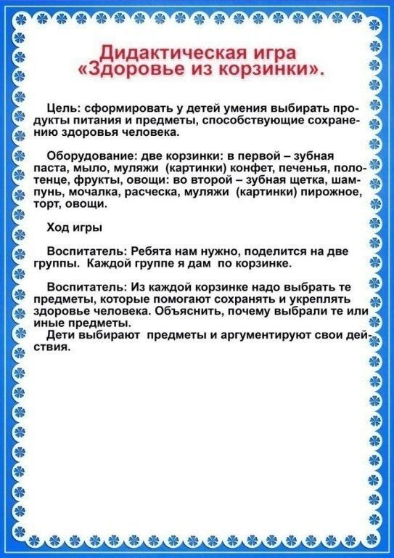](https://ok.ru/dk?cmd=PopLayerPhoto&st.layer.cmd=PopLayerPhotoOuter&st.layer.type=GROUP&st.layer.revNav=off&st.layer.limitedUi=false&st.layer.closeLayers=off&st.layer.sphotoIds=902350332852;902350333108;902350333364;902350333620;902350333876;902350334132;902350334388;902350334644&st.layer.showNav=on&st.layer.photoAlbumId=53660988735668&st.layer.epm=off&st.layer.photoId=902350334132&st.layer.wasRedirect,=off&st.layer.opl=off&st.layer.navStartPhotoId=902350334132&st.layer.navStartAlbumId,=53660988735668&st.layer.sbd=off&st.cmd=altGroupForum&st.groupId=53660977529012&st._aid=GroupTopicLayer_openPhotoLayer)

[](https://ok.ru/dk?cmd=PopLayerPhoto&st.layer.cmd=PopLayerPhotoOuter&st.layer.type=GROUP&st.layer.revNav=off&st.layer.limitedUi=false&st.layer.closeLayers=off&st.layer.sphotoIds=902350332852;902350333108;902350333364;902350333620;902350333876;902350334132;902350334388;902350334644&st.layer.showNav=on&st.layer.photoAlbumId=53660988735668&st.layer.epm=off&st.layer.photoId=902350334388&st.layer.wasRedirect,=off&st.layer.opl=off&st.layer.navStartPhotoId=902350334388&st.layer.navStartAlbumId,=53660988735668&st.layer.sbd=off&st.cmd=altGroupForum&st.groupId=53660977529012&st._aid=GroupTopicLayer_openPhotoLayer)

[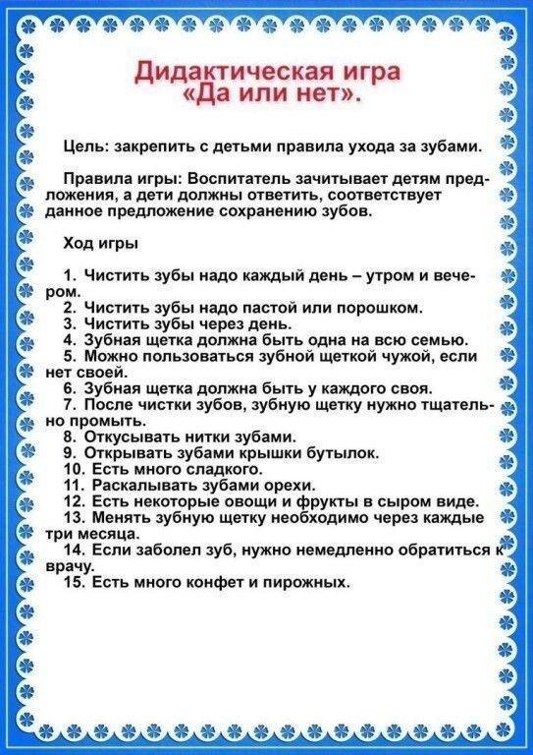](https://ok.ru/dk?cmd=PopLayerPhoto&st.layer.cmd=PopLayerPhotoOuter&st.layer.type=GROUP&st.layer.revNav=off&st.layer.limitedUi=false&st.layer.closeLayers=off&st.layer.sphotoIds=902350332852;902350333108;902350333364;902350333620;902350333876;902350334132;902350334388;902350334644&st.layer.showNav=on&st.layer.photoAlbumId=53660988735668&st.layer.epm=off&st.layer.photoId=902350334644&st.layer.wasRedirect,=off&st.layer.opl=off&st.layer.navStartPhotoId=902350334644&st.layer.navStartAlbumId,=53660988735668&st.layer.sbd=off&st.cmd=altGroupForum&st.groupId=53660977529012&st._aid=GroupTopicLayer_openPhotoLayer)