[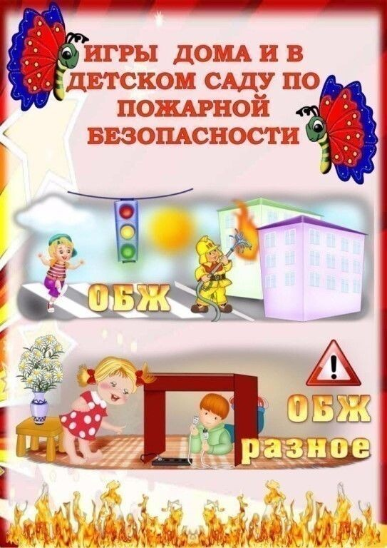](https://ok.ru/dk?cmd=PopLayerPhoto&st.layer.cmd=PopLayerPhotoOuter&st.layer.type=GROUP&st.layer.revNav=off&st.layer.limitedUi=false&st.layer.closeLayers=off&st.layer.sphotoIds=902304116660;902304116916;902304117172;902304117428;902304117684;902304117940;902304118196;902304118452;902304118708&st.layer.showNav=on&st.layer.photoAlbumId=53660988735668&st.layer.epm=off&st.layer.photoId=902304116660&st.layer.wasRedirect,=off&st.layer.opl=off&st.layer.navStartPhotoId=902304116660&st.layer.navStartAlbumId,=53660988735668&st.layer.sbd=off&st.cmd=altGroupForum&st.groupId=53660977529012&st._aid=GroupTopicLayer_openPhotoLayer)

[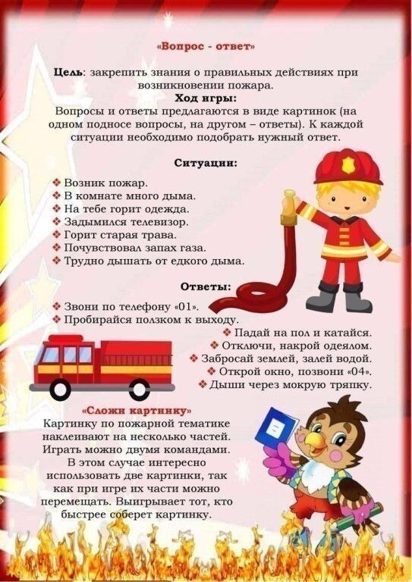](https://ok.ru/dk?cmd=PopLayerPhoto&st.layer.cmd=PopLayerPhotoOuter&st.layer.type=GROUP&st.layer.revNav=off&st.layer.limitedUi=false&st.layer.closeLayers=off&st.layer.sphotoIds=902304116660;902304116916;902304117172;902304117428;902304117684;902304117940;902304118196;902304118452;902304118708&st.layer.showNav=on&st.layer.photoAlbumId=53660988735668&st.layer.epm=off&st.layer.photoId=902304116916&st.layer.wasRedirect,=off&st.layer.opl=off&st.layer.navStartPhotoId=902304116916&st.layer.navStartAlbumId,=53660988735668&st.layer.sbd=off&st.cmd=altGroupForum&st.groupId=53660977529012&st._aid=GroupTopicLayer_openPhotoLayer)

[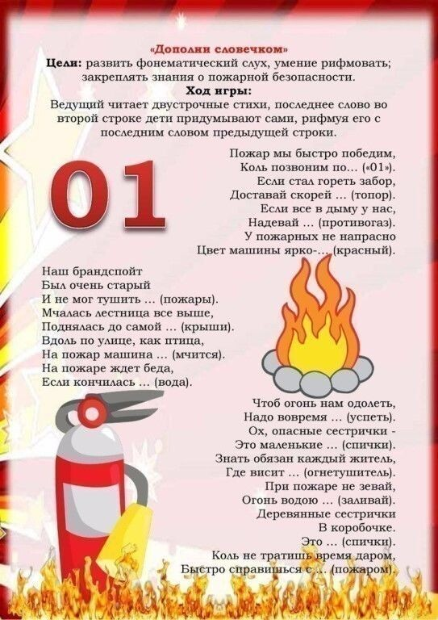](https://ok.ru/dk?cmd=PopLayerPhoto&st.layer.cmd=PopLayerPhotoOuter&st.layer.type=GROUP&st.layer.revNav=off&st.layer.limitedUi=false&st.layer.closeLayers=off&st.layer.sphotoIds=902304116660;902304116916;902304117172;902304117428;902304117684;902304117940;902304118196;902304118452;902304118708&st.layer.showNav=on&st.layer.photoAlbumId=53660988735668&st.layer.epm=off&st.layer.photoId=902304117172&st.layer.wasRedirect,=off&st.layer.opl=off&st.layer.navStartPhotoId=902304117172&st.layer.navStartAlbumId,=53660988735668&st.layer.sbd=off&st.cmd=altGroupForum&st.groupId=53660977529012&st._aid=GroupTopicLayer_openPhotoLayer)

[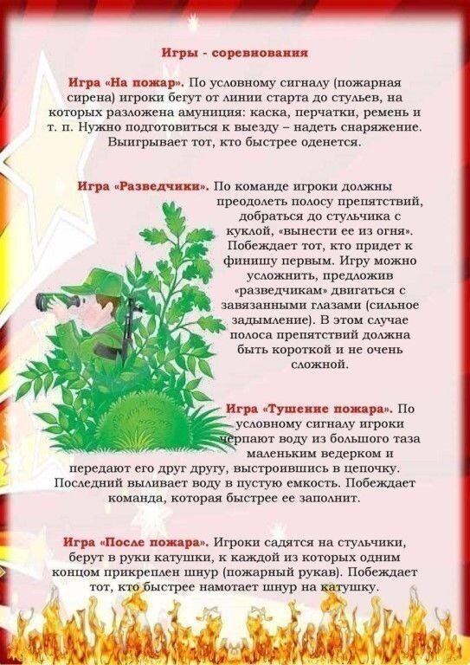](https://ok.ru/dk?cmd=PopLayerPhoto&st.layer.cmd=PopLayerPhotoOuter&st.layer.type=GROUP&st.layer.revNav=off&st.layer.limitedUi=false&st.layer.closeLayers=off&st.layer.sphotoIds=902304116660;902304116916;902304117172;902304117428;902304117684;902304117940;902304118196;902304118452;902304118708&st.layer.showNav=on&st.layer.photoAlbumId=53660988735668&st.layer.epm=off&st.layer.photoId=902304117428&st.layer.wasRedirect,=off&st.layer.opl=off&st.layer.navStartPhotoId=902304117428&st.layer.navStartAlbumId,=53660988735668&st.layer.sbd=off&st.cmd=altGroupForum&st.groupId=53660977529012&st._aid=GroupTopicLayer_openPhotoLayer)

[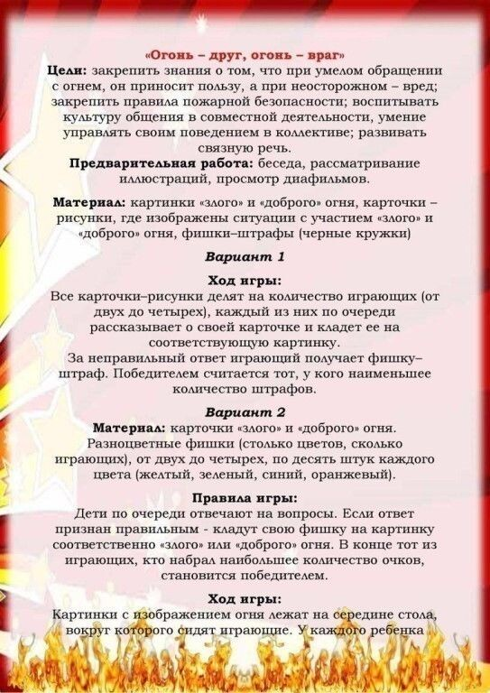](https://ok.ru/dk?cmd=PopLayerPhoto&st.layer.cmd=PopLayerPhotoOuter&st.layer.type=GROUP&st.layer.revNav=off&st.layer.limitedUi=false&st.layer.closeLayers=off&st.layer.sphotoIds=902304116660;902304116916;902304117172;902304117428;902304117684;902304117940;902304118196;902304118452;902304118708&st.layer.showNav=on&st.layer.photoAlbumId=53660988735668&st.layer.epm=off&st.layer.photoId=902304117684&st.layer.wasRedirect,=off&st.layer.opl=off&st.layer.navStartPhotoId=902304117684&st.layer.navStartAlbumId,=53660988735668&st.layer.sbd=off&st.cmd=altGroupForum&st.groupId=53660977529012&st._aid=GroupTopicLayer_openPhotoLayer)

[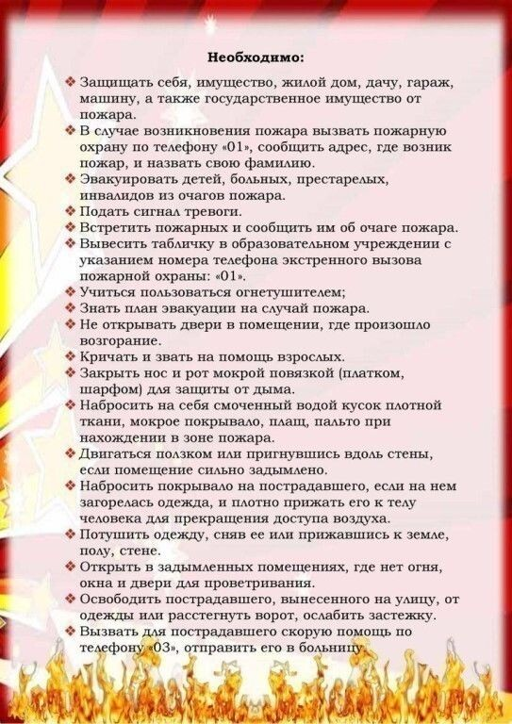](https://ok.ru/dk?cmd=PopLayerPhoto&st.layer.cmd=PopLayerPhotoOuter&st.layer.type=GROUP&st.layer.revNav=off&st.layer.limitedUi=false&st.layer.closeLayers=off&st.layer.sphotoIds=902304116660;902304116916;902304117172;902304117428;902304117684;902304117940;902304118196;902304118452;902304118708&st.layer.showNav=on&st.layer.photoAlbumId=53660988735668&st.layer.epm=off&st.layer.photoId=902304117940&st.layer.wasRedirect,=off&st.layer.opl=off&st.layer.navStartPhotoId=902304117940&st.layer.navStartAlbumId,=53660988735668&st.layer.sbd=off&st.cmd=altGroupForum&st.groupId=53660977529012&st._aid=GroupTopicLayer_openPhotoLayer)

[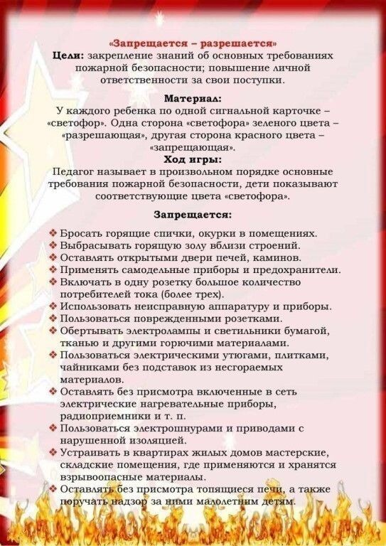](https://ok.ru/dk?cmd=PopLayerPhoto&st.layer.cmd=PopLayerPhotoOuter&st.layer.type=GROUP&st.layer.revNav=off&st.layer.limitedUi=false&st.layer.closeLayers=off&st.layer.sphotoIds=902304116660;902304116916;902304117172;902304117428;902304117684;902304117940;902304118196;902304118452;902304118708&st.layer.showNav=on&st.layer.photoAlbumId=53660988735668&st.layer.epm=off&st.layer.photoId=902304118196&st.layer.wasRedirect,=off&st.layer.opl=off&st.layer.navStartPhotoId=902304118196&st.layer.navStartAlbumId,=53660988735668&st.layer.sbd=off&st.cmd=altGroupForum&st.groupId=53660977529012&st._aid=GroupTopicLayer_openPhotoLayer)

[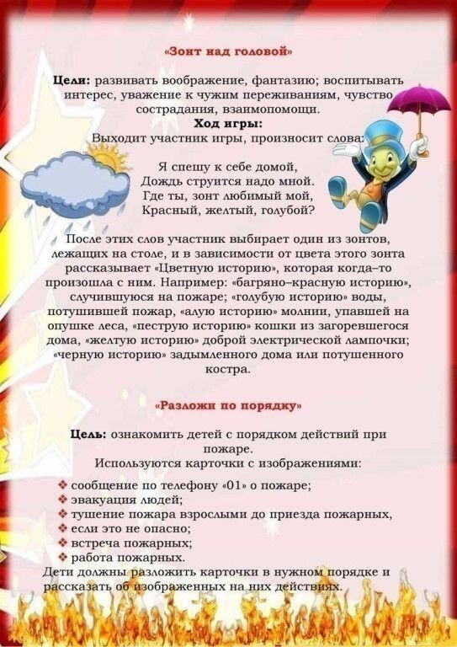](https://ok.ru/dk?cmd=PopLayerPhoto&st.layer.cmd=PopLayerPhotoOuter&st.layer.type=GROUP&st.layer.revNav=off&st.layer.limitedUi=false&st.layer.closeLayers=off&st.layer.sphotoIds=902304116660;902304116916;902304117172;902304117428;902304117684;902304117940;902304118196;902304118452;902304118708&st.layer.showNav=on&st.layer.photoAlbumId=53660988735668&st.layer.epm=off&st.layer.photoId=902304118452&st.layer.wasRedirect,=off&st.layer.opl=off&st.layer.navStartPhotoId=902304118452&st.layer.navStartAlbumId,=53660988735668&st.layer.sbd=off&st.cmd=altGroupForum&st.groupId=53660977529012&st._aid=GroupTopicLayer_openPhotoLayer)

[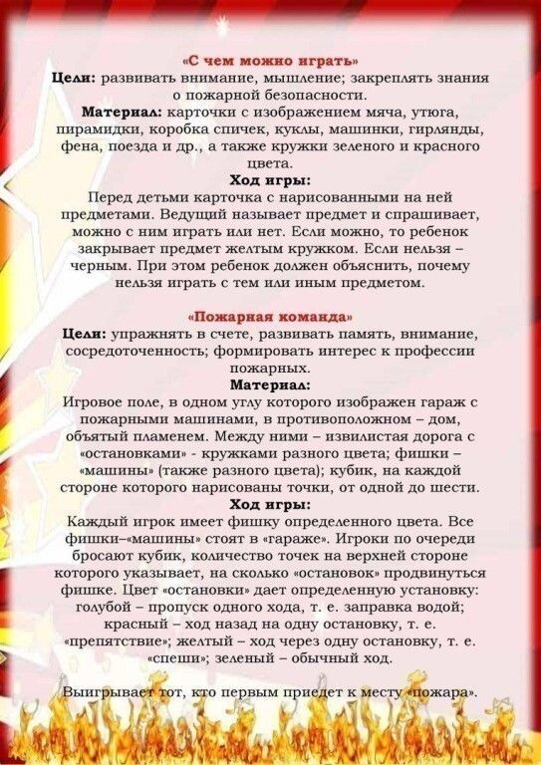](https://ok.ru/dk?cmd=PopLayerPhoto&st.layer.cmd=PopLayerPhotoOuter&st.layer.type=GROUP&st.layer.revNav=off&st.layer.limitedUi=false&st.layer.closeLayers=off&st.layer.sphotoIds=902304116660;902304116916;902304117172;902304117428;902304117684;902304117940;902304118196;902304118452;902304118708&st.layer.showNav=on&st.layer.photoAlbumId=53660988735668&st.layer.epm=off&st.layer.photoId=902304118708&st.layer.wasRedirect,=off&st.layer.opl=off&st.layer.navStartPhotoId=902304118708&st.layer.navStartAlbumId,=53660988735668&st.layer.sbd=off&st.cmd=altGroupForum&st.groupId=53660977529012&st._aid=GroupTopicLayer_openPhotoLayer)