[](https://ok.ru/dk?cmd=PopLayerPhoto&st.layer.cmd=PopLayerPhotoOuter&st.layer.type=GROUP&st.layer.revNav=off&st.layer.limitedUi=false&st.layer.closeLayers=off&st.layer.sphotoIds=865120109236;865120109492;865120109748;865120110004;865120110260;865120110516;865120110772;865120111028&st.layer.showNav=on&st.layer.photoAlbumId=53660988735668&st.layer.epm=off&st.layer.photoId=865120109236&st.layer.wasRedirect,=off&st.layer.opl=off&st.layer.navStartPhotoId=865120109236&st.layer.navStartAlbumId,=53660988735668&st.layer.sbd=off&st.cmd=altGroupForum&st.groupId=53660977529012&st.referenceName=group53660977529012&st._aid=GroupTopicLayer_openPhotoLayer)

[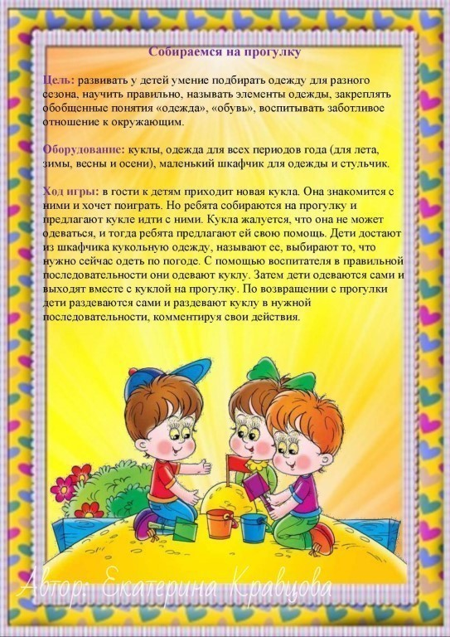](https://ok.ru/dk?cmd=PopLayerPhoto&st.layer.cmd=PopLayerPhotoOuter&st.layer.type=GROUP&st.layer.revNav=off&st.layer.limitedUi=false&st.layer.closeLayers=off&st.layer.sphotoIds=865120109236;865120109492;865120109748;865120110004;865120110260;865120110516;865120110772;865120111028&st.layer.showNav=on&st.layer.photoAlbumId=53660988735668&st.layer.epm=off&st.layer.photoId=865120109492&st.layer.wasRedirect,=off&st.layer.opl=off&st.layer.navStartPhotoId=865120109492&st.layer.navStartAlbumId,=53660988735668&st.layer.sbd=off&st.cmd=altGroupForum&st.groupId=53660977529012&st.referenceName=group53660977529012&st._aid=GroupTopicLayer_openPhotoLayer)

[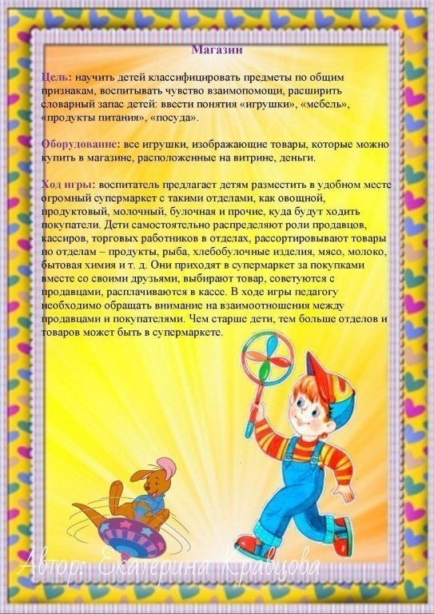](https://ok.ru/dk?cmd=PopLayerPhoto&st.layer.cmd=PopLayerPhotoOuter&st.layer.type=GROUP&st.layer.revNav=off&st.layer.limitedUi=false&st.layer.closeLayers=off&st.layer.sphotoIds=865120109236;865120109492;865120109748;865120110004;865120110260;865120110516;865120110772;865120111028&st.layer.showNav=on&st.layer.photoAlbumId=53660988735668&st.layer.epm=off&st.layer.photoId=865120109748&st.layer.wasRedirect,=off&st.layer.opl=off&st.layer.navStartPhotoId=865120109748&st.layer.navStartAlbumId,=53660988735668&st.layer.sbd=off&st.cmd=altGroupForum&st.groupId=53660977529012&st.referenceName=group53660977529012&st._aid=GroupTopicLayer_openPhotoLayer)

[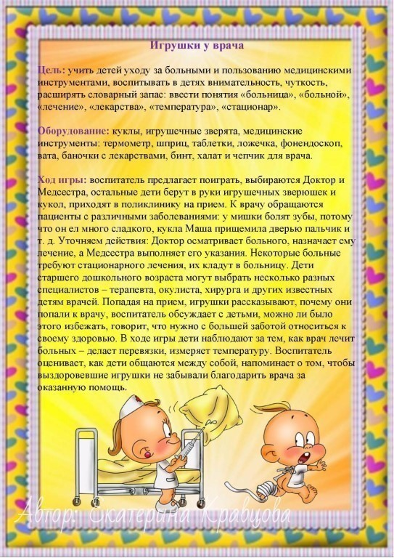](https://ok.ru/dk?cmd=PopLayerPhoto&st.layer.cmd=PopLayerPhotoOuter&st.layer.type=GROUP&st.layer.revNav=off&st.layer.limitedUi=false&st.layer.closeLayers=off&st.layer.sphotoIds=865120109236;865120109492;865120109748;865120110004;865120110260;865120110516;865120110772;865120111028&st.layer.showNav=on&st.layer.photoAlbumId=53660988735668&st.layer.epm=off&st.layer.photoId=865120110004&st.layer.wasRedirect,=off&st.layer.opl=off&st.layer.navStartPhotoId=865120110004&st.layer.navStartAlbumId,=53660988735668&st.layer.sbd=off&st.cmd=altGroupForum&st.groupId=53660977529012&st.referenceName=group53660977529012&st._aid=GroupTopicLayer_openPhotoLayer)

[](https://ok.ru/dk?cmd=PopLayerPhoto&st.layer.cmd=PopLayerPhotoOuter&st.layer.type=GROUP&st.layer.revNav=off&st.layer.limitedUi=false&st.layer.closeLayers=off&st.layer.sphotoIds=865120109236;865120109492;865120109748;865120110004;865120110260;865120110516;865120110772;865120111028&st.layer.showNav=on&st.layer.photoAlbumId=53660988735668&st.layer.epm=off&st.layer.photoId=865120110260&st.layer.wasRedirect,=off&st.layer.opl=off&st.layer.navStartPhotoId=865120110260&st.layer.navStartAlbumId,=53660988735668&st.layer.sbd=off&st.cmd=altGroupForum&st.groupId=53660977529012&st.referenceName=group53660977529012&st._aid=GroupTopicLayer_openPhotoLayer)

[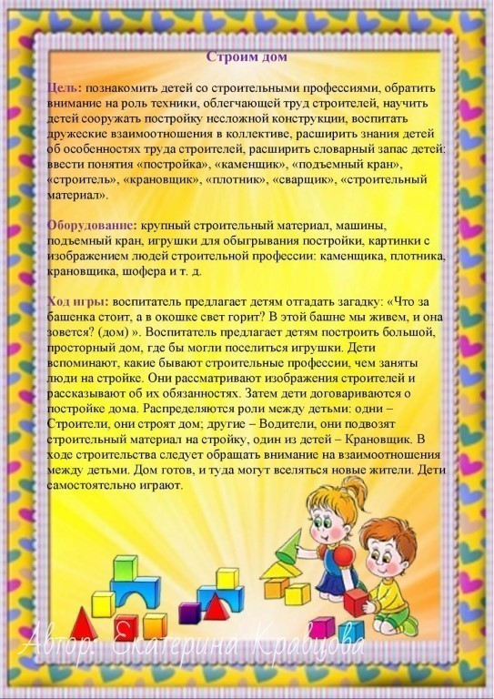](https://ok.ru/dk?cmd=PopLayerPhoto&st.layer.cmd=PopLayerPhotoOuter&st.layer.type=GROUP&st.layer.revNav=off&st.layer.limitedUi=false&st.layer.closeLayers=off&st.layer.sphotoIds=865120109236;865120109492;865120109748;865120110004;865120110260;865120110516;865120110772;865120111028&st.layer.showNav=on&st.layer.photoAlbumId=53660988735668&st.layer.epm=off&st.layer.photoId=865120110516&st.layer.wasRedirect,=off&st.layer.opl=off&st.layer.navStartPhotoId=865120110516&st.layer.navStartAlbumId,=53660988735668&st.layer.sbd=off&st.cmd=altGroupForum&st.groupId=53660977529012&st.referenceName=group53660977529012&st._aid=GroupTopicLayer_openPhotoLayer)

[](https://ok.ru/dk?cmd=PopLayerPhoto&st.layer.cmd=PopLayerPhotoOuter&st.layer.type=GROUP&st.layer.revNav=off&st.layer.limitedUi=false&st.layer.closeLayers=off&st.layer.sphotoIds=865120109236;865120109492;865120109748;865120110004;865120110260;865120110516;865120110772;865120111028&st.layer.showNav=on&st.layer.photoAlbumId=53660988735668&st.layer.epm=off&st.layer.photoId=865120110772&st.layer.wasRedirect,=off&st.layer.opl=off&st.layer.navStartPhotoId=865120110772&st.layer.navStartAlbumId,=53660988735668&st.layer.sbd=off&st.cmd=altGroupForum&st.groupId=53660977529012&st.referenceName=group53660977529012&st._aid=GroupTopicLayer_openPhotoLayer)

[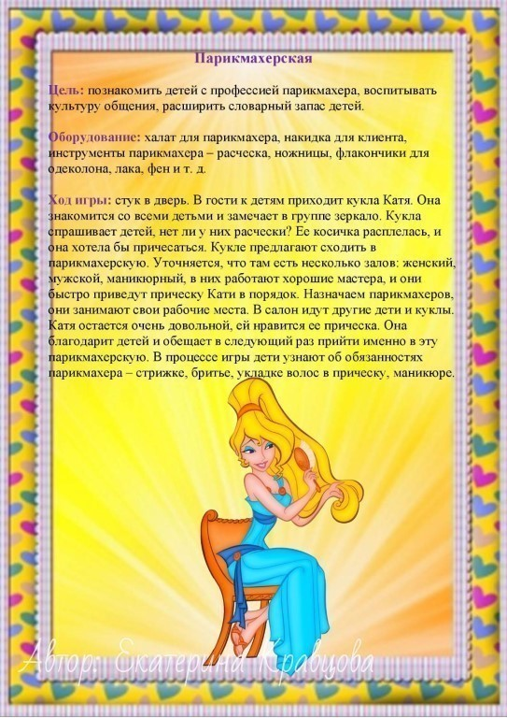](https://ok.ru/dk?cmd=PopLayerPhoto&st.layer.cmd=PopLayerPhotoOuter&st.layer.type=GROUP&st.layer.revNav=off&st.layer.limitedUi=false&st.layer.closeLayers=off&st.layer.sphotoIds=865120109236;865120109492;865120109748;865120110004;865120110260;865120110516;865120110772;865120111028&st.layer.showNav=on&st.layer.photoAlbumId=53660988735668&st.layer.epm=off&st.layer.photoId=865120111028&st.layer.wasRedirect,=off&st.layer.opl=off&st.layer.navStartPhotoId=865120111028&st.layer.navStartAlbumId,=53660988735668&st.layer.sbd=off&st.cmd=altGroupForum&st.groupId=53660977529012&st.referenceName=group53660977529012&st._aid=GroupTopicLayer_openPhotoLayer)