ПАЛЬЧИКОВЫЕ ИГРЫ [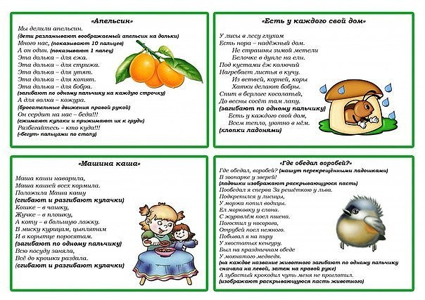](https://ok.ru/dk?cmd=PopLayerPhoto&st.layer.cmd=PopLayerPhotoOuter&st.layer.type=GROUP&st.layer.revNav=off&st.layer.limitedUi=false&st.layer.closeLayers=off&st.layer.sphotoIds=866345985460;866345985716;866345985972;866345986228;866345986484;866345986740;866345986996;866345987252;866345987508&st.layer.showNav=on&st.layer.photoAlbumId=53660988735668&st.layer.epm=off&st.layer.photoId=866345985460&st.layer.wasRedirect,=off&st.layer.opl=off&st.layer.navStartPhotoId=866345985460&st.layer.navStartAlbumId,=53660988735668&st.layer.sbd=off&st.cmd=altGroupForum&st.groupId=53660977529012&st.referenceName=group53660977529012&st._aid=GroupTopicLayer_openPhotoLayer)

[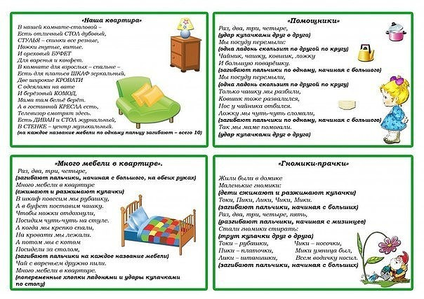](https://ok.ru/dk?cmd=PopLayerPhoto&st.layer.cmd=PopLayerPhotoOuter&st.layer.type=GROUP&st.layer.revNav=off&st.layer.limitedUi=false&st.layer.closeLayers=off&st.layer.sphotoIds=866345985460;866345985716;866345985972;866345986228;866345986484;866345986740;866345986996;866345987252;866345987508&st.layer.showNav=on&st.layer.photoAlbumId=53660988735668&st.layer.epm=off&st.layer.photoId=866345985716&st.layer.wasRedirect,=off&st.layer.opl=off&st.layer.navStartPhotoId=866345985716&st.layer.navStartAlbumId,=53660988735668&st.layer.sbd=off&st.cmd=altGroupForum&st.groupId=53660977529012&st.referenceName=group53660977529012&st._aid=GroupTopicLayer_openPhotoLayer)

[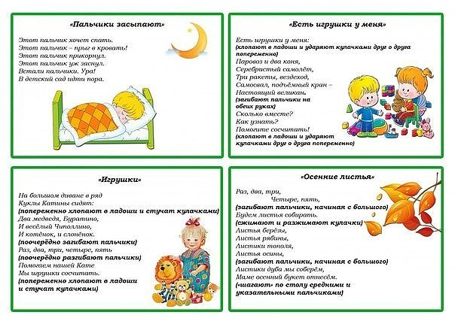](https://ok.ru/dk?cmd=PopLayerPhoto&st.layer.cmd=PopLayerPhotoOuter&st.layer.type=GROUP&st.layer.revNav=off&st.layer.limitedUi=false&st.layer.closeLayers=off&st.layer.sphotoIds=866345985460;866345985716;866345985972;866345986228;866345986484;866345986740;866345986996;866345987252;866345987508&st.layer.showNav=on&st.layer.photoAlbumId=53660988735668&st.layer.epm=off&st.layer.photoId=866345985972&st.layer.wasRedirect,=off&st.layer.opl=off&st.layer.navStartPhotoId=866345985972&st.layer.navStartAlbumId,=53660988735668&st.layer.sbd=off&st.cmd=altGroupForum&st.groupId=53660977529012&st.referenceName=group53660977529012&st._aid=GroupTopicLayer_openPhotoLayer)

[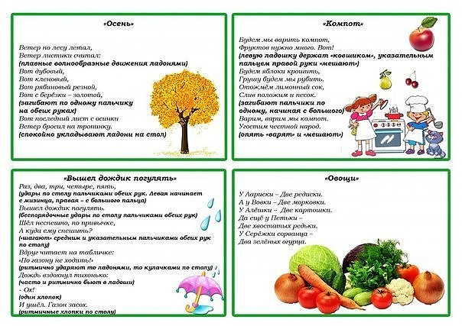](https://ok.ru/dk?cmd=PopLayerPhoto&st.layer.cmd=PopLayerPhotoOuter&st.layer.type=GROUP&st.layer.revNav=off&st.layer.limitedUi=false&st.layer.closeLayers=off&st.layer.sphotoIds=866345985460;866345985716;866345985972;866345986228;866345986484;866345986740;866345986996;866345987252;866345987508&st.layer.showNav=on&st.layer.photoAlbumId=53660988735668&st.layer.epm=off&st.layer.photoId=866345986228&st.layer.wasRedirect,=off&st.layer.opl=off&st.layer.navStartPhotoId=866345986228&st.layer.navStartAlbumId,=53660988735668&st.layer.sbd=off&st.cmd=altGroupForum&st.groupId=53660977529012&st.referenceName=group53660977529012&st._aid=GroupTopicLayer_openPhotoLayer)

[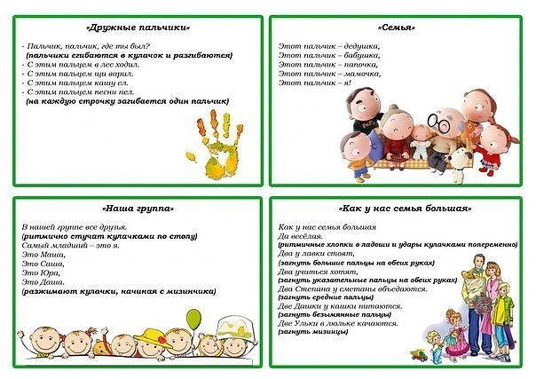](https://ok.ru/dk?cmd=PopLayerPhoto&st.layer.cmd=PopLayerPhotoOuter&st.layer.type=GROUP&st.layer.revNav=off&st.layer.limitedUi=false&st.layer.closeLayers=off&st.layer.sphotoIds=866345985460;866345985716;866345985972;866345986228;866345986484;866345986740;866345986996;866345987252;866345987508&st.layer.showNav=on&st.layer.photoAlbumId=53660988735668&st.layer.epm=off&st.layer.photoId=866345986484&st.layer.wasRedirect,=off&st.layer.opl=off&st.layer.navStartPhotoId=866345986484&st.layer.navStartAlbumId,=53660988735668&st.layer.sbd=off&st.cmd=altGroupForum&st.groupId=53660977529012&st.referenceName=group53660977529012&st._aid=GroupTopicLayer_openPhotoLayer)

[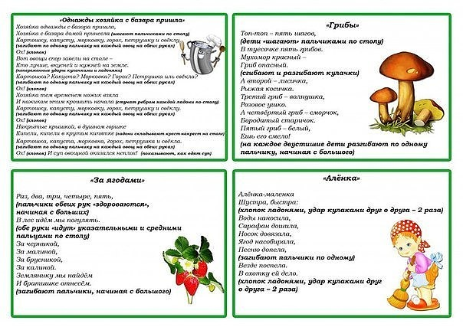](https://ok.ru/dk?cmd=PopLayerPhoto&st.layer.cmd=PopLayerPhotoOuter&st.layer.type=GROUP&st.layer.revNav=off&st.layer.limitedUi=false&st.layer.closeLayers=off&st.layer.sphotoIds=866345985460;866345985716;866345985972;866345986228;866345986484;866345986740;866345986996;866345987252;866345987508&st.layer.showNav=on&st.layer.photoAlbumId=53660988735668&st.layer.epm=off&st.layer.photoId=866345986740&st.layer.wasRedirect,=off&st.layer.opl=off&st.layer.navStartPhotoId=866345986740&st.layer.navStartAlbumId,=53660988735668&st.layer.sbd=off&st.cmd=altGroupForum&st.groupId=53660977529012&st.referenceName=group53660977529012&st._aid=GroupTopicLayer_openPhotoLayer)

[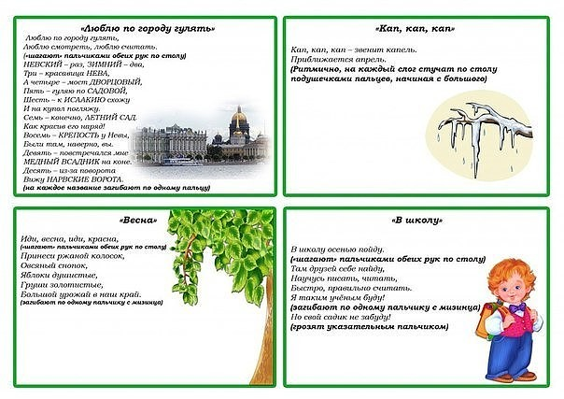](https://ok.ru/dk?cmd=PopLayerPhoto&st.layer.cmd=PopLayerPhotoOuter&st.layer.type=GROUP&st.layer.revNav=off&st.layer.limitedUi=false&st.layer.closeLayers=off&st.layer.sphotoIds=866345985460;866345985716;866345985972;866345986228;866345986484;866345986740;866345986996;866345987252;866345987508&st.layer.showNav=on&st.layer.photoAlbumId=53660988735668&st.layer.epm=off&st.layer.photoId=866345986996&st.layer.wasRedirect,=off&st.layer.opl=off&st.layer.navStartPhotoId=866345986996&st.layer.navStartAlbumId,=53660988735668&st.layer.sbd=off&st.cmd=altGroupForum&st.groupId=53660977529012&st.referenceName=group53660977529012&st._aid=GroupTopicLayer_openPhotoLayer)

[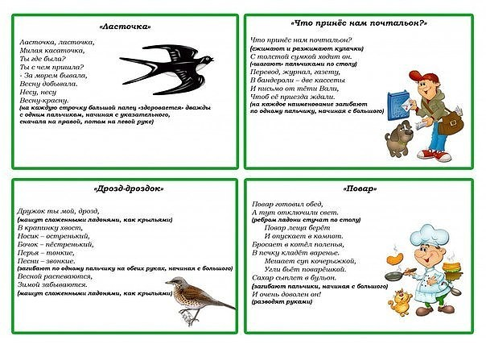](https://ok.ru/dk?cmd=PopLayerPhoto&st.layer.cmd=PopLayerPhotoOuter&st.layer.type=GROUP&st.layer.revNav=off&st.layer.limitedUi=false&st.layer.closeLayers=off&st.layer.sphotoIds=866345985460;866345985716;866345985972;866345986228;866345986484;866345986740;866345986996;866345987252;866345987508&st.layer.showNav=on&st.layer.photoAlbumId=53660988735668&st.layer.epm=off&st.layer.photoId=866345987252&st.layer.wasRedirect,=off&st.layer.opl=off&st.layer.navStartPhotoId=866345987252&st.layer.navStartAlbumId,=53660988735668&st.layer.sbd=off&st.cmd=altGroupForum&st.groupId=53660977529012&st.referenceName=group53660977529012&st._aid=GroupTopicLayer_openPhotoLayer)

[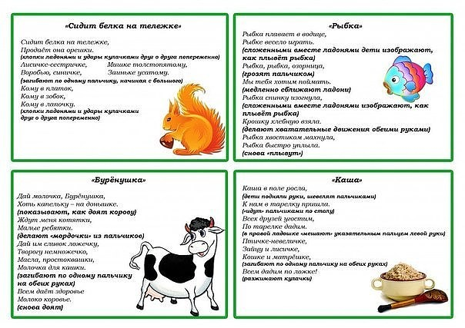](https://ok.ru/dk?cmd=PopLayerPhoto&st.layer.cmd=PopLayerPhotoOuter&st.layer.type=GROUP&st.layer.revNav=off&st.layer.limitedUi=false&st.layer.closeLayers=off&st.layer.sphotoIds=866345985460;866345985716;866345985972;866345986228;866345986484;866345986740;866345986996;866345987252;866345987508&st.layer.showNav=on&st.layer.photoAlbumId=53660988735668&st.layer.epm=off&st.layer.photoId=866345987508&st.layer.wasRedirect,=off&st.layer.opl=off&st.layer.navStartPhotoId=866345987508&st.layer.navStartAlbumId,=53660988735668&st.layer.sbd=off&st.cmd=altGroupForum&st.groupId=53660977529012&st.referenceName=group53660977529012&st._aid=GroupTopicLayer_openPhotoLayer)