#развивайка #картотека #игра

[](https://ok.ru/dk?cmd=PopLayerPhoto&st.layer.cmd=PopLayerPhotoOuter&st.layer.type=GROUP&st.layer.revNav=off&st.layer.limitedUi=false&st.layer.closeLayers=off&st.layer.sphotoIds=865906407092;865906407348;865906407604;865906407860;865906408116;865906408372;865906408628;865906408884&st.layer.showNav=on&st.layer.photoAlbumId=53660988735668&st.layer.epm=off&st.layer.photoId=865906407092&st.layer.wasRedirect,=off&st.layer.opl=off&st.layer.navStartPhotoId=865906407092&st.layer.navStartAlbumId,=53660988735668&st.layer.sbd=off&st.cmd=altGroupForum&st.groupId=53660977529012&st.referenceName=group53660977529012&st._aid=GroupTopicLayer_openPhotoLayer)

[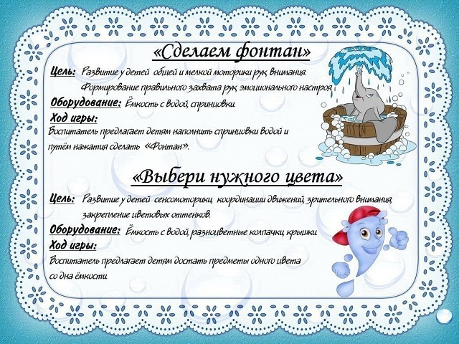](https://ok.ru/dk?cmd=PopLayerPhoto&st.layer.cmd=PopLayerPhotoOuter&st.layer.type=GROUP&st.layer.revNav=off&st.layer.limitedUi=false&st.layer.closeLayers=off&st.layer.sphotoIds=865906407092;865906407348;865906407604;865906407860;865906408116;865906408372;865906408628;865906408884&st.layer.showNav=on&st.layer.photoAlbumId=53660988735668&st.layer.epm=off&st.layer.photoId=865906407348&st.layer.wasRedirect,=off&st.layer.opl=off&st.layer.navStartPhotoId=865906407348&st.layer.navStartAlbumId,=53660988735668&st.layer.sbd=off&st.cmd=altGroupForum&st.groupId=53660977529012&st.referenceName=group53660977529012&st._aid=GroupTopicLayer_openPhotoLayer)

[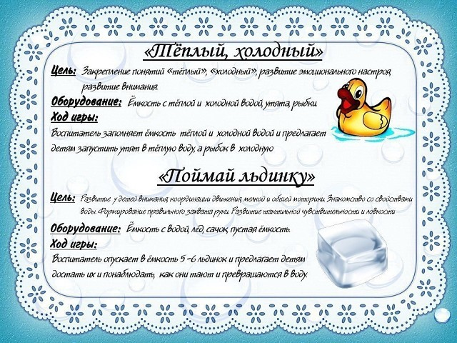](https://ok.ru/dk?cmd=PopLayerPhoto&st.layer.cmd=PopLayerPhotoOuter&st.layer.type=GROUP&st.layer.revNav=off&st.layer.limitedUi=false&st.layer.closeLayers=off&st.layer.sphotoIds=865906407092;865906407348;865906407604;865906407860;865906408116;865906408372;865906408628;865906408884&st.layer.showNav=on&st.layer.photoAlbumId=53660988735668&st.layer.epm=off&st.layer.photoId=865906407604&st.layer.wasRedirect,=off&st.layer.opl=off&st.layer.navStartPhotoId=865906407604&st.layer.navStartAlbumId,=53660988735668&st.layer.sbd=off&st.cmd=altGroupForum&st.groupId=53660977529012&st.referenceName=group53660977529012&st._aid=GroupTopicLayer_openPhotoLayer)

[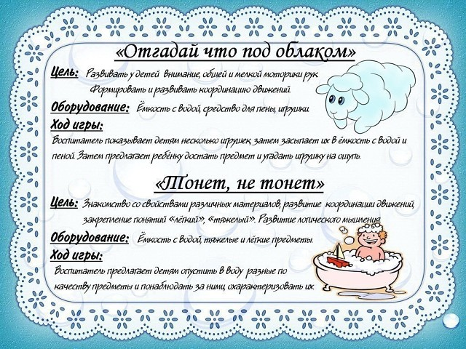](https://ok.ru/dk?cmd=PopLayerPhoto&st.layer.cmd=PopLayerPhotoOuter&st.layer.type=GROUP&st.layer.revNav=off&st.layer.limitedUi=false&st.layer.closeLayers=off&st.layer.sphotoIds=865906407092;865906407348;865906407604;865906407860;865906408116;865906408372;865906408628;865906408884&st.layer.showNav=on&st.layer.photoAlbumId=53660988735668&st.layer.epm=off&st.layer.photoId=865906407860&st.layer.wasRedirect,=off&st.layer.opl=off&st.layer.navStartPhotoId=865906407860&st.layer.navStartAlbumId,=53660988735668&st.layer.sbd=off&st.cmd=altGroupForum&st.groupId=53660977529012&st.referenceName=group53660977529012&st._aid=GroupTopicLayer_openPhotoLayer)

[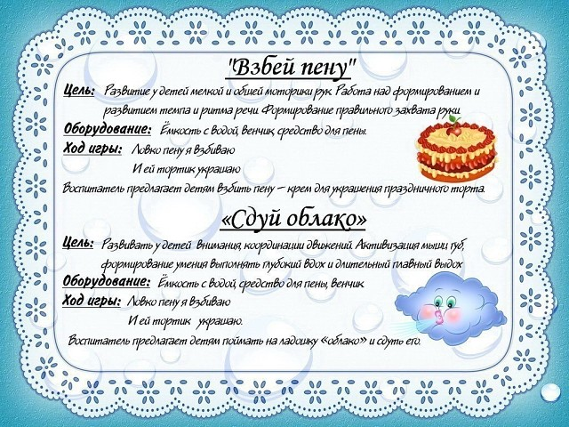](https://ok.ru/dk?cmd=PopLayerPhoto&st.layer.cmd=PopLayerPhotoOuter&st.layer.type=GROUP&st.layer.revNav=off&st.layer.limitedUi=false&st.layer.closeLayers=off&st.layer.sphotoIds=865906407092;865906407348;865906407604;865906407860;865906408116;865906408372;865906408628;865906408884&st.layer.showNav=on&st.layer.photoAlbumId=53660988735668&st.layer.epm=off&st.layer.photoId=865906408116&st.layer.wasRedirect,=off&st.layer.opl=off&st.layer.navStartPhotoId=865906408116&st.layer.navStartAlbumId,=53660988735668&st.layer.sbd=off&st.cmd=altGroupForum&st.groupId=53660977529012&st.referenceName=group53660977529012&st._aid=GroupTopicLayer_openPhotoLayer)

[](https://ok.ru/dk?cmd=PopLayerPhoto&st.layer.cmd=PopLayerPhotoOuter&st.layer.type=GROUP&st.layer.revNav=off&st.layer.limitedUi=false&st.layer.closeLayers=off&st.layer.sphotoIds=865906407092;865906407348;865906407604;865906407860;865906408116;865906408372;865906408628;865906408884&st.layer.showNav=on&st.layer.photoAlbumId=53660988735668&st.layer.epm=off&st.layer.photoId=865906408372&st.layer.wasRedirect,=off&st.layer.opl=off&st.layer.navStartPhotoId=865906408372&st.layer.navStartAlbumId,=53660988735668&st.layer.sbd=off&st.cmd=altGroupForum&st.groupId=53660977529012&st.referenceName=group53660977529012&st._aid=GroupTopicLayer_openPhotoLayer)

[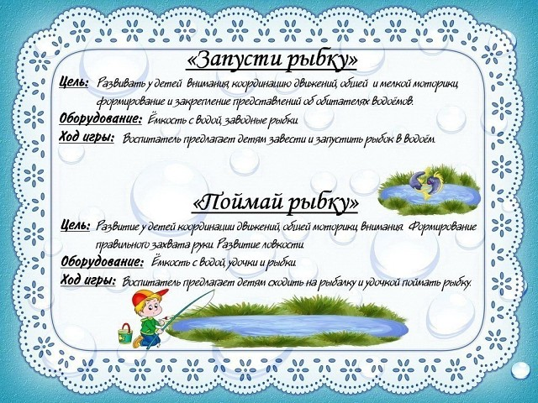](https://ok.ru/dk?cmd=PopLayerPhoto&st.layer.cmd=PopLayerPhotoOuter&st.layer.type=GROUP&st.layer.revNav=off&st.layer.limitedUi=false&st.layer.closeLayers=off&st.layer.sphotoIds=865906407092;865906407348;865906407604;865906407860;865906408116;865906408372;865906408628;865906408884&st.layer.showNav=on&st.layer.photoAlbumId=53660988735668&st.layer.epm=off&st.layer.photoId=865906408628&st.layer.wasRedirect,=off&st.layer.opl=off&st.layer.navStartPhotoId=865906408628&st.layer.navStartAlbumId,=53660988735668&st.layer.sbd=off&st.cmd=altGroupForum&st.groupId=53660977529012&st.referenceName=group53660977529012&st._aid=GroupTopicLayer_openPhotoLayer)

[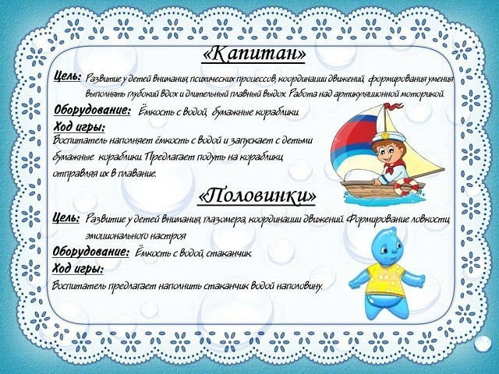](https://ok.ru/dk?cmd=PopLayerPhoto&st.layer.cmd=PopLayerPhotoOuter&st.layer.type=GROUP&st.layer.revNav=off&st.layer.limitedUi=false&st.layer.closeLayers=off&st.layer.sphotoIds=865906407092;865906407348;865906407604;865906407860;865906408116;865906408372;865906408628;865906408884&st.layer.showNav=on&st.layer.photoAlbumId=53660988735668&st.layer.epm=off&st.layer.photoId=865906408884&st.layer.wasRedirect,=off&st.layer.opl=off&st.layer.navStartPhotoId=865906408884&st.layer.navStartAlbumId,=53660988735668&st.layer.sbd=off&st.cmd=altGroupForum&st.groupId=53660977529012&st.referenceName=group53660977529012&st._aid=GroupTopicLayer_openPhotoLayer)